## Coaching Tools

## ake Charge of Your Talent - Andi Roberts Coaching

## A sample of simple tools used by Andi Roberts MBA in his work as a business coach

If used and adapted please place “based on work developed by Andi Roberts of www.masterfacilitator.com”

## Coaching Tool: Mind Mapping

**When it’s used**

Mind Mapping has many uses within the coaching context:

As a focused brainstorm

As an exploration of an issue

As a decision making tool

As a planning tool

**How to set up the session**

* To effectively Mind Map you will need a large piece of paper such as A3 size and a variety of coloured pencils.
* Explain how to draw a mind map.
* Coach the PBC to add on and extend the map.
* When the map is fully developed coach around the output.
* When used as a decision making tool +’s and –‘s can be used to evaluate the branches or scores can be given to different ideas and then these can be summed.

**How to draw a mind map**

1. Generate a topic. What will be the focus of your thinking? Your topic should be no more than a few words. By keeping your topic simple, you will be able to understand more aspects of it through the map. A broader topic will give you more with which to work in the future.
2. Place that topic in the centre of the page. Write it in bold letters. Circle or place a square around the topic.
3. Start writing what comes to mind. As you generate thoughts, draw a branch from the main topic. Keep it to as few words as possible. Print clearly.
4. 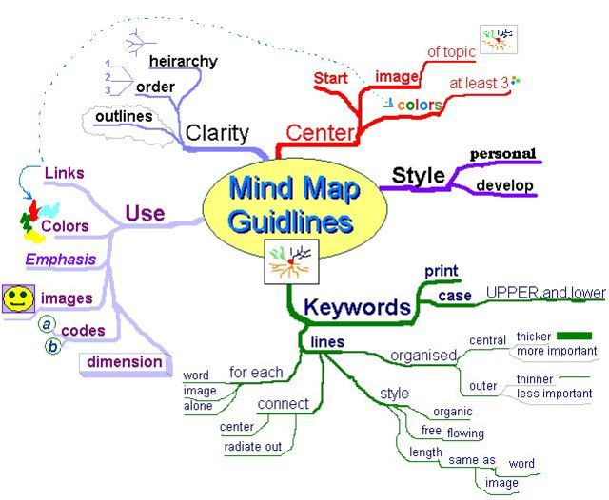Begin branching. Try to extend your thoughts from one idea to the next. Draw lines between thoughts to create lateral thinking. Number your ideas to create organization.
5. As new ideas come forth, draw a different branch from your topic.
6. Repeat branching until all your ideas appear on the map.
7. Use colours, drawings and symbols to create a richer picture.

## Coaching Tool : Force Field Diagram

**When it’s used**

The Force Field Diagram developed by Kurt Lewin is used principally to understand the drivers for a change and the restrainers that may stop or slow down a change. It can also be used to:

* List pro's and con's.
* List actions and reactions.
* List strengths and weaknesses.
* Compare ideal situations and reality.
* In negotiation, compare the perceptions of opposing parties.
* List "what we know" in the left column, and "what we don't know" in the right.

**How to set up the session**

* To effectively diagram a force field diagram you will need a large piece of paper such as A3 size and some marker or thick pens
* Explain how to draw the diagram
* Coach the PBC to list all of ideas to go on either side of the diagram
* When the diagram is fully developed coach around the output. Specifically around how to reduce or remove the issues that have been drawn on the chart.

**How to draw a Force Field Diagram**

* 1. Write a statement that describes the decision or situation to be resolved. In particular, it should help points for and against the argument to be identified. Write this statement in the top-centre of the paper or whiteboard.
  2. Draw a vertical line below the statement, and write 'For' at the top on the left and 'Against' on the right.
  3. Ask the PBC to identify the key arguments for and against the problem.  Write these points on the left or on the right of the line, as appropriate. Do *not* yet draw any lines arrows under them.
  4. Identify the criteria to use for deciding on the importance of each item. For example, if the problem is about delivery times, the criteria may be, 'meets commitment to customer' and 'not too expensive'. If the PBC cannot decide on a criteria to use, it may highlight an underlying problem. It is usually worth taking some time to discuss and resolve this sub-problem.
  5. Take each argument in turn, discuss it, and use the criteria from step 4 to help identify how important it is. For an unimportant argument, draw a short arrow underneath it, pointing into the centre line. For an important item, draw a long arrow.
  6. You can get quite structured about this by having a scale of 1 to 5 to indicate the strength of the argument, Draw the arrows bigger or smaller depending on the strength.
  7. Stand back and look at the completed Force-Field Diagram. Does the answer jump out at you? If it is clear, then well and good. Otherwise spend more time discussing the individual forces, or find data to ensure the forces are based on fact, rather than opinion.
  8. If you used a scale in step 5, then you can add up the strength points from either side to give 'total strength' figures for the arguments for and against.

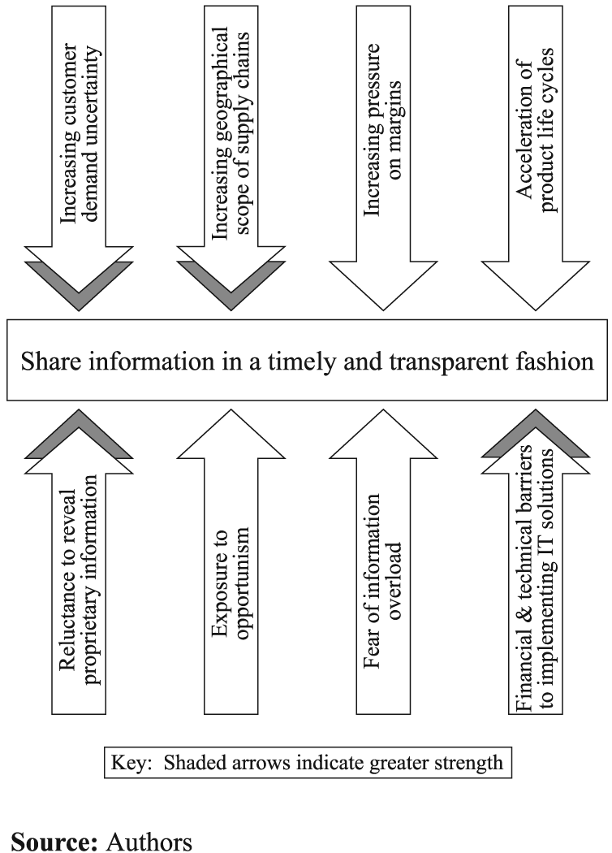

## Coaching Tool : Rich Picture

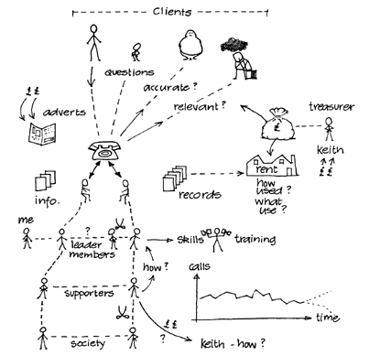**When it’s used**

The Rich Picture which originates from Soft Systems Methodology by Peter Checkland is a visual tool that get’s the PBC to think about and draw a situation. It is best when used when the issue is fairly complex or the PBC has trouble expressing or exploring the issue in depth. Rich pictures are used to depict complicated situations. They are an attempt to encapsulate the real situation through a no- holds-barred, cartoon representation of all the ideas covered already layout, connections, relationships, influences, cause-and-effect, and so on. As well as these objective notions, rich pictures should depict subjective elements such as character and characteristics, points of view and prejudices, spirit and human nature.

**How to set up the session**

* To effectively diagram a Rich Picture diagram you will need a large piece of paper such as A3 size and some marker or thick pens
* Explain how to draw the diagram
* Coach the PBC to add depth to the picture
* When the diagram is fully developed coach around the output. Specifically around how the key elements of the drawing and their inter-relationships.

**How to draw a Rich Picture**

1. A rich picture is an attempt to assemble everything that might be relevant to a complex situation. You should somehow represent every observation that occurs to you or that you gleaned from your initial survey.
2. Fall back on words only where ideas fail you for a sketch that encapsulates your meaning.
3. You should not seek to impose any style or structure on your picture. Place the elements on your sheet wherever your instinct prompts. At a later stage you may find that the placement itself has a message for you.
4. If you ‘don’t know where to begin’, then the following sequence may help to get you started:
   1. first look for the elements of structure in the situation (these are the parts of the situation that change relatively slowly over time and are relatively stable, the people, the set-ups, the command hierarchy, perhaps);
   2. next look for elements of process within the situation (these are the things that are in a state of change: the activities that are going on);
   3. then look for the ways in which the structure and the processes interact. Doing this will give you an idea of the climate of the situation. That is, the ways in which the structure and the processes relate to each other.
5. Avoid thinking in systems terms. That is, using ideas like: ‘Well, the situation is made up of a marketing system and a production system and a quality control system’. There are two reasons for this. The first is that the word ‘system’ implies organized interconnections and it may be precisely the absence of such organized interconnectedness that lies at the heart of the matter: therefore, by assuming its existence (by the use of the word system) you may be missing the point. Note, however, that this does not mean that there won’t be some sort of link or connection between your graphics, as mentioned above. The second reason is that doing so will channel you down a particular line of thought, namely the search for ways of making these systems more efficient.
6. Make sure that your picture includes not only the factual data about the situation, but also the subjective information.
7. Look at the social roles that are regarded within the situation as meaningful by those involved, and look at the kinds of behaviour expected from people in those roles. If you see any conflicts, indicate them.
8. Finally, include yourself in the picture. Make sure that your roles and relationships in the situation are clear. Remember that you are not an objective observer, but someone with a set of values, beliefs and norms that colour your perceptions.

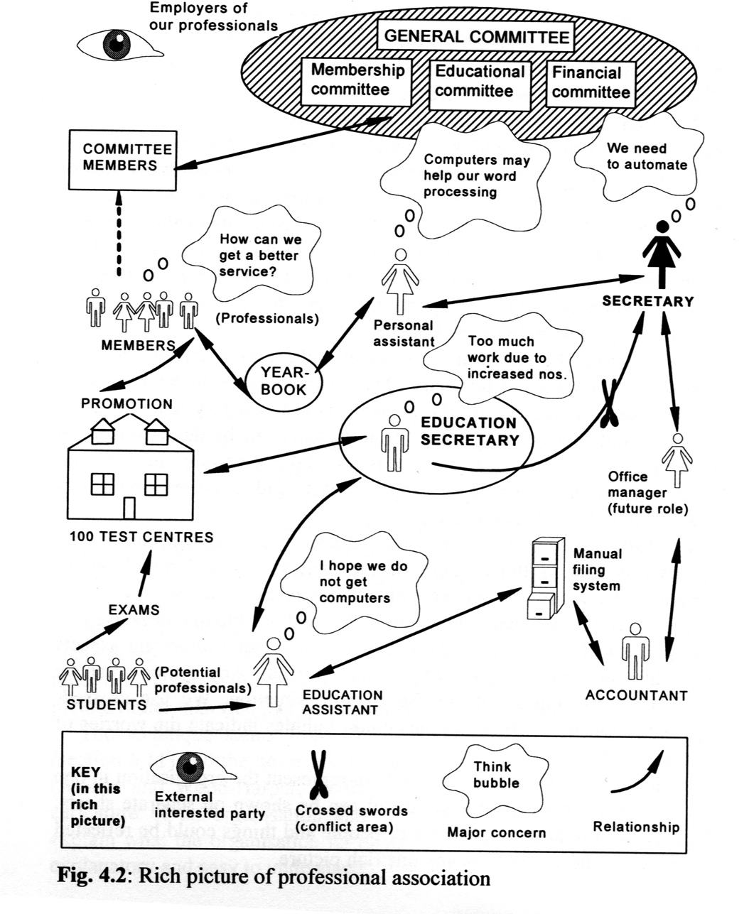The mnemonic “CATWOE” is used to help people remember the elements of the Rich Picture:

* Customers – internal or external
* Actors – all of the people involved
* Transformation – the changes that happen in the picture
* Worldview – a macro view of what is happening, like a “fly on the wall”
* Owner – where does the PBC fit in to the diagram
* Environment – What elements of the environment are there and where do they fit in

The Rich Picture is typically drawn before the analysis phase of the coaching conversation.Coaching Tool : Two by Two Matrix

**When it’s used**

A 2 x 2 Matrix is a simple tool to define and analyse qualitative data or ideas that can be mapped against two critical variables that are important in an issue.

**How to set up the session**

Little set up is needed for this session just a pencil, eraser and paper and possibly a template.

**How to draw a 2 x 2 Matrix**

The following is an example 2 x 2 Matrix session. The way this is setup can change depending on the 2 x 2 grid being used. The following example is for supporting a PBC get on top of time management

Step 1 : Define the topic to focus on using the tool and the axis that will be mapped In this case time / task management is the focus and the axis will be Urgency (Y Axis) and Importance ( X Axis).

Step 2 : List all of the items to be mapped onto the diagram. Challenge the PBC to develop a full holistic list. In this example the tasks or To Do list items that the PBC has on their plate. For each item give it a list number i.e. the 1st item would be 1, the 2nd 2 etc so that all items have a number.

Step 3 : Assign the items a score for the X Axis on a scale of 1 to 10, with 10 being high. In the case being developed here this would mean that importance of the tasks in the PBC’s To Do list.



Step 4 : Carry out the same process as in step 3 for the Y Axis.

Step 5 : Plot the items on a graph by placing the number of the item at the correct place, using the scores as coordinates.

Step 5 : Once all of the items have been plotted on the graph then the focus can be coaching around the output in terms of observations and insights.

Step 6 : further steps may be taken depending on the graph. For example in this example the tasks have been given circles with the sizes of the circles showing how much time each task will need.

**2 x 2 Grid Template**

**2 x 2 Variations**



**Support & Challenge**  
Gets the PBC to think about the current projects or tasks they are carrying out.  
1 – They should list out all of their current projects or tasks.  
2 – They should then assign a rating of challenge level for each task (1 to 10 with 10 as high).  
3 – They should then assign a rating of level of support for each task (1 to 10 with 10 as high).  
Typically if there are many tasks that have high challenge and low support stress tends to occur and they then need to look at how they can get the appropriate levels of support for their challenges.

**Impact & Ease of Implementation**  
This 2 x 2 gets the PBC to think through a list of ideas or changes that they want to implement in the business.  
1 – They should list all of the ideas out.  
2 – They should then assign a rating of the impact the idea will have on the business ( 1 to 10 with1 being little impact and 10 being high impact ).  
3 – They should then assign a rating on the ease of putting the idea into practise ( 1 to 10 with 1 being a very easy thing to implement and 10 being significantly difficult to implement in terms of time, resources and human impact).  
The coaching session may focus on the pros and cons of different options and ways of achieving success with the project.

**Ability & Engagement**  
This 2 x 2 gets the PBC to think about the team they have on board and what they may need to do develop them to increase their performance.  
1 – They PBC should list all of their team members.  
2 – They should then assign a rating based on the ability level of their team member ( 1 to 10 with 1 being low ability and 10 being outstanding ).  
3 – They should then assign a rating based on their estimated level of work engagement with the work they carry out and the company at large ( 1 to 10 with 1 being a very poor level of engagement and 10 being fantastic almost fanatical engagement ).  
The coaching session would probably look first at the awareness created by the grid and then move into coaching around how to get increased levels of ability or engagement for some individuals.

Coaching Tool : Coaching Circle

**When it’s used**

The coaching circle can be used in many moments of a coaching conversation. It is particularly useful when starting a coaching process or an issue or challenge has many facets that need to be looked at. The Coaching Circle is the basis for a goal setting process and ongoing checking and coaching.

**How to set up the session**

Little set up is needed for this session just a pencil, eraser and paper and either a blank template or a prepared template depending on the issue.

**How to use the Coaching Circle**

The following is an example of a predefined coaching circle around facilities management:

Step 1 : On a scale of 1 to 10, with 10 being high, how important the following elements are to the business unit:

* Customer Satisfaction of the facility manager
* Customer satisfaction of the end user of the services
* Staff engagement
* Facility leadership team engagement
* Innovation
* Quality
* Financial management of the facility
* Alignment with the business plan for the facility

Mark the answers to these question on the diagram on the appropriate line

Step 2 : On a scale of 1 to 10, with 10 being high define how things are TODAY with each of the same eight areas. Starting in the centre of the diagram shade in each section based on the number given in this step.

Step 3 : Based on the outcomes and the game define which of the eight areas are the top priorities. Typically three areas are chosen as the top three to work on in the coaching process.

Step 4 : Coach around each of the top 3 topics and use the diagram as a tracking tool for the coaching process

NOTE : You can define 8 topics for a different coaching processes or when working with the PBC you can ask them to name eight aspects of a topics and start from there on a blank template i.e. “What do you think could be 8 areas that are important to employee engagement?”

**Empty Coaching Circle**



**Completed Coaching Circle**



**Coaching Circle Template**

Coaching Tool : Cosmos Clarity diagram



**When it’s used**

The Cosmos Clarity Diagram is based on the excellent book by Stephan R. Covey “The 7 Habits of Highly Effective People” . In this book Habit 1 is “Be Proactive” and that means that effective people focus on things that they can control or those things that they can influence rather than worry about those things that they cannot impact in any way. In this way they become more proactive. The tool is an excellent one to use when the PBC is “dancing around” an issue or has a lack of clarity. The four areas of the diagrams are:

* Area of control : Things that the PBC can actually implement themself.
* Area of direct influence : Things that the PBC can influence through direct contact with another person.
* Area of indirect influence : Things that the PBC can’t influence directly but where some indirect opportunity through another person.
* Area of concern : Things that are on the mind of the PBC but they are out there in the great cosmos and can not be impacted.

**How to set up the session**

Little set up is needed for this session just a pencil, eraser and paper and either a blank template or a blank piece of paper. This tool can also be linked to various variations of the 2 x 2 diagram and other tools.

**How to use the Cosmos Clarity diagram**

Step 1 : Start of the session by defining what the coaching focus is. An example may be “Increase employee engagement”.

Step 2 : Once the topic is defined get the PBC to develop an extensive list of all of the things that came to his/her mind when they think of this topic. The more ideas and thoughts the better. Take time to explore this rather than doing a “quick and dirty”.

Step 3 : Draw the diagram or use the template and get the PBC to place the ideas or thoughts on the diagram in the correct place. Be aware that as a coach you may need to challenge the PBC’s thinking around where they put an issue.

Step 4 : Coach around the results. Place particular focus on new awareness gained by doing the activity and also changes in what their original ideas were on the topic.

**Cosmos Clarity Diagram**

## Coaching Tool : Strengths Sorter



Aim

This document is a self assessment of personal strengths. There is no right or wrong answer or even the correct strengths to have. Each person is unique and that is the combination of education, experience and values that help develop a persons strengths. This activity is not psychometric and you may choose to share the information with others or not. It is for you to reflect on your own style and abilities.

Instructions

1 – Print out this document

2 – Cut out the table named “Strength’s Cards” in to 37 separate cards

3 – Working on a large table or flat space carry out the initial sorting process

Place the 3 column cards at the top of the table in the order from left to right “My Strengths”, “Neither Strength Nor Weakness”, My weakness’ ”. You should think about those strengths / traits / ways of being that you are most like most of the time.

Take your time and sort out the 34 cards in a line below the column cards

11 Cards that you believe describe your best strengths.

11 Cards the you believe describe your weaknesses.

The remaining 12 cards go in the middle column that are neither.

If you are unsure of the meaning / explanation of a card look up on a dictionary the meaning of the title and the key words of an explanation. If you are still unsure use a thesaurus to look up alternative titles for the card. If online try [www.referance.com](http://www.referance.com) which has a dictionary and thesaurus or <http://en.wiktionary.org> .

Take a break or do something else for at least 30 minutes and then return to the list and re-examine your choices. Swap cards around if necessary.

4 – Write down on the sheet named “Strength Sort Initial List”, the initial list from the three columns.

5 – Clear away the columns and cards from “Neither Strength Nor Weakness”, My weakness’ leaving just strengths cards on the table.

6 – Carry out a swap sort process on these cards.

* Examine the bottom two cards of the column of cards.
* Ask yourself of the two, which is a greater strength, the bottom one or the one above it. If the answer is the bottom card then swop them around.
* Carry on this process with the last but one and the one above it.
* Keep this process going so that eventually you will have examined each pair of cards and your biggest strengths will have migrated up the list to the top.

Again take a break and come back to the cards and do the process after say 30 minutes or more.

7 – Write down this list in the section titled “My Top 5 Strengths & Reflections”.

8 – Reflect on this list by answering the questions in the reflections section.

My Top 5 Strengths & Reflections

My top 5 Strengths are

1.

2.

3.

4.

5.

What are my initial reactions having done this process?

How do my strengths manifest themselves in my day to day living?

How can I use my strengths to make me evening more productive in helping me achieve my goals?

What is one key “take away” that I have gained from going through this Strength Sorter Activity process?

**Strength Sort Initial List**

Write down on this sheet your initial Strengths list.

|  |  |  |
| --- | --- | --- |
| **My Strengths** | **Neither Strength nor Weaknesses** | **My weaknesses** |
|  |  |  |
|  |  |  |
|  |  |  |
|  |  |  |
|  |  |  |
|  |  |  |
|  |  |  |
|  |  |  |
|  |  |  |
|  |  |  |
|  |  |  |
|  |  |  |

**Strengths Cards**

Cut out the cards on the following sheets.

|  |  |  |
| --- | --- | --- |
| **Column Card**  **My Strengths** | **Column Card**  **Neither Strength nor Weaknesses** | **Column Card**  **My weaknesses** |
| **Dynamo**  Has a great deal of stamina and likes to work hard. Thrives on being busy and productive. | **Energiser**  Likes to turn thought into action. Thrives on putting ideas into practise. Does not like to hang around. | **Accommodator**  Likes to take things as they come. Happy with uncertainty knowing that the future will sort its self out. |
| **Diagnostic**  Likes to search for the reasons and causes of issues. Thrives on thorough thinking before taking action. Very analytical. | **Developer**  Likes to organise things but is flexible in the approach. Thrives on connecting resources to attain maximum productivity. | **Conviction**  Keeps to certain core values. These values support the life purpose of the person. These values show up in how this person lives and makes decisions. |
| **Conductor**  Creates a strong presence. Thrives on decision making and taking control when required. | **Speaker**  Is able to communicate well. Is very comfortable putting across their ideas and find presenting easy. | **Challenger**  Likes to measure there progress against their peers. They thrive on the pressure of competition. |
| **Affiliated**  Believes strongly in the links that binds them to other things and people. They believe that things happen for a purpose. | **Constancy**  Believes that everyone should be treated equally. Ensures that rules are adhered to by all no matter what race or position is held. | **Background**  Believes that what happens in the present has a strong connection with the past. Thrives on understanding what happened previously to better understand the present. |
| **Calculating**  Believes that good decisions are made by taking serious care in the analytical process. They anticipate potential obstacles. | **Facilitator**  Believes in achieving success by developing others. They look to encourage and support learning in others knowing it will also help them. | **Self Control**  Believes in the need for routine and structure. They enjoy being planned and organised ahead of time. |
| **Appreciation**  Are very good at sensing the feelings of others. They are able to place themselves in other people’s situations. | **Purpose**  Creates clarity on objectives and follows through to ensure it/they is carried out. They prioritise and adjust where required but ensure the task gets done. | **Visionary**  They are future focused and inspired by the possibilities the future holds. They inspire and motivate others to engage in their ideas for the future. |
| **Harmony**  Creates consensus. They are skilled in getting joint agreement to avoid conflict. | **Encompassing**  They believe strongly in accepting the ideas and opinions of other. The are very aware of knowing who is left out and how to bring them in to the fold. | **Ideation**.  They are skilled in the development of ideas. They are excellent at connecting what looks like disparate data. |
| **Individualization**  They are studiers of the unique differences in people. They are skilled at understanding how very different people can draw on their strengths to work together well. | **Learner**  They are always interested in knowing more, They are keen collector and archivers of information. | **Scholarly**  They are people who are keen on intellectual activity. They like to debate and are often introspective in that they turn inwards to make decisions. |
| **Maximizer**  Is strengths focused and stimulates people and teams to do their best with their gifts. Likes to take things from good to even better. | **Positivists**  Are very upbeat and enthusiastic. They are excited by what they are going to do and spread that enthusiasm in others. | **Relator**  Are very friendship orientated, they work hard and at a deep level with friends to achieve common goals. They spend time improving and developing their relationships. |
| **Committed**  Are very focused on ensuring that they do what they say they will. They value honesty, loyalty and hard work to get things done. | **Problem solving**  People who are skilled at sorting out problems from a psychological and mental standpoint. They have strong resolve when issues appear. | **Self Assured**  People who are confident in their own abilities to get things done and at the same time confident that their ideas will work. |
| **Prestige**  People who want to be seen as important in the eyes of others. They wish to recognised by others and a generally independent. | **Acute**  People who are able to study a scenario and quickly develop and evaluate different scenarios. They tend to be good at spotting relevant pattern and reading between the lines to get to the real issues. | **Networker**  People who enjoy meeting new people and establishing relationships. They are comfortable breaking the ice and being the soul of the social event. |

Coaching Tool : Team Template

**When it’s used**

The Team Template is a coaching tool for team coaching or working with a team leader through a series of areas that a team needs to have clarity about in order to be effective.

**How to set up the session**

The session with the Team Template can be done in one of two ways.

**Set up 1 – with the team present**

If working with the team, the key thing is to have buy in from the team leader. The session is typically a ½ day affair and as the coach you work through the template with the team. In this set up it is important to get the team leader to clarify the team mission first and have this on the chart ready for the session.

To prepare the session you will need to draw up on flip chart paper a complete Team Template using 4 pieces of flipchart paper joined together in a 2 x 2 fashion.

Once this is done you facilitate the team through the session in the following order:

* 1. Clarify and confirm the team mission.
  2. Develop the team’s values. This can be done by discussion or by using the Values Sorter activity in this pack. If you use the Values Sorter activity you can get participants to carry out the activity and then share common values. These common values can be shared and used as a basis for discussion around what should be the team’s core values
  3. Develop the Team Charter which are the 10 ground rules that this team agree to work by. This is done by getting the team to discuss and flipchart their key ideas and then vote, perhaps, using sticky dots or ticks which 10 ground rules are the most important. If the group is large you may want to separate into break out groups and then pull across the key points that are common to the different flipcharts. The Team Charter can be thought of as the practical day to day use of the values and so there should be some linkage between the values and the Team Charter.
  4. Develop Team Strengths & Development Opportunities. This can be done through discussion, brain storming or by small group discussion and feedback. Ideally here there should be no more than 5 points on either side of the chart.
  5. Develop the issues to tackle. Again this is dealt with through facilitated discussion. Depending on the time you have available you may be able to action plan and resolves some of these issues in the session or they could become the focus for future sessions.

**Set up 2 – with the team leader**

The process is the same without the team except that the team template gets the team leader to work through the same areas and decide the content or go back to the team and work with them through some of the pieces. If the tool is used with the leader it may take several sessions to clarify all of the different points. As a coach you may want to suggest that you facilitate key sessions such as the values and charter with the team and that the rest is done one on one with the team leader.

**How to use the Team Template**

Once the template has been fully developed it becomes a tracking and coaching tool. The different issues can be used as the focus for different coaching sessions moving forward.

**Team Template**



## Coaching Tool : Values Sorter

**Step 1: What I Value Most...**

From this list of values (both work and personal), select the ten that are most important to you-as guides for how to behave, or as components of a valued way of life.

|  |  |  |
| --- | --- | --- |
| Achievement | Friendships | Physical challenge |
| Advancement and promotion | Growth | Pleasure |
| Adventure | Having a family | Power and authority |
| Affection (love and caring) | Helping other people | Privacy |
| Arts | Helping society | Public service |
| Challenging problems | Honesty | Purity |
| Change and variety | Independence | Quality of what I take part in |
| Close relationships | Influencing others | Quality relationships |
| Community | Inner harmony | Recognition (respect from others, status) |
| Competence | Integrity | Religion |
| Competition | Intellectual status | Reputation |
| Cooperation | Involvement | Responsibility and accountability |
| Country | Job tranquillity | Security |
| Creativity | Knowledge | Self-respect |
| Decisiveness | Leadership | Serenity |
| Democracy | Location | Sophistication |
| Ecological awareness | Loyalty | Stability |
| Economic security | Market position | Status |
| Effectiveness | Meaningful work | Supervising others |
| Efficiency | Merit | Time freedom |
| Ethical practice | Money | Truth |
| Excellence | Nature | Wealth |
| Excitement | Being around people who are open and honest | Wisdom |
| Fame | Order (tranquillity, stability, conformity) | Work under pressure |
| Fast living | Personal development | Work with others |
| Financial gain | Freedom | Working alone |

**Step 2 : Other values**

Are there other values that are important to you that were not mentioned above. If so write them down.

**Step 3: Elimination**

Now that you have identified ten and any of you own not mentioned values, imagine that you are only permitted to have five values. Which others would you give up? Cross them off and write down below the top 5.

1.

2.

3.

4.

5.

**Step 4 : Questions**

What self awareness have you gained from this activity?

How do these values play out in your daily life?

What happens when others work in a spirit that is not in line with your values?

Other thoughts?

## Coaching Tool –Six Hats Thinking process

**When it’s used**

The classic six hats methods is a tool that was championed by Edward De Bono to empower people to think in different ways rather than the ways they have always done. In the context of coaching it is an excellent tool to get a client to think in new and different ways. Coloured hats are used as metaphors for each state and make it easier to use as people don’t feel judged or pidgin holed into a particular form of thinking. Instead ot saying the phrase “be creative” you can say “put your green hat on and go creative” which is much more neutral in content.

**How to set up the session**

Explain to the client the six distinct states of thinking in the “Thinking Hats” process and their assigned colours:

* Questions (White) - considering purely what information is available, what are the facts?
* Emotions (Red) - instinctive gut reaction or statements of emotional feeling (but not any justification)
* Bad points judgment (Black) - logic applied to identifying flaws or barriers, seeking mismatch
* Good points judgment (Yellow) - logic applied to identifying benefits, seeking harmony
* Creativity (Green) - statements of provocation and investigation, seeing where a thought goes
* Thinking (Blue) - thinking about thinking

Depending on the session you may just challenge the client to use one or two specific hats. You can also use a full flow of hats to explore an issue. Suggested flows are :

Exploring initial Ideas - Blue, White, Green, Blue

Choosing between alternative ideas or actions - Blue, White, (Green), Yellow, Black, Red, Blue

Identifying solutions to an issue- Blue, White, Black, Green, Blue

Providing quick feedback to someone on an issue - Blue, Black, Green, Blue

A full strategic planning process - Blue, Yellow, Black, White, Blue, Green, Blue

Process Improvement - Blue, White, White (Other peoples views), Yellow, Black, Green, Red, Blue

Solving business problems - Blue, White, Green, Red, Yellow, Black, Green, Blue

Carrying out a performance review - Blue, Red, White, Yellow, Black, Green, Red, Blue

**De Bono’s Six Hats**

**White hat – Facts & Information**

The PBC makes statements of fact, including identifying information that is absent and presenting the views of people who are not present in a factual manner. In many thinking sessions this occurs immediately after an initial blue hat, and it often an extended action with the PBC presenting details about their organization and the background to the purpose of the thinking session. The key information that represents the inputs to the session are presented and discussed. Key absences of information (i.e. information needs) can also be identified at this point.

Business examples are:

* Total sales of this product are €x p.a.
* Our sales data is two years old
* Energy efficiency legislation is expected to impact our ability to run our business in the next five years
* The number of young staff in the business is increasing

**Red hat – Feelings & Emotions**

The PBC states their feelings, exercising their gut instincts. In many cases this is a method for harvesting ideas - it is not a question of recording statements, but rather getting the PBC to identify their top two or three choices from a list of ideas or items identified under another hat. This is done to help reducing lists of many options into a few to focus on by allowing to decide the ones they prefer. It is applied more quickly than the other hats to ensure it is a gut reaction feeling that is recorded. Finally this hat can be used to request an aesthetic response to a particular design or object

Business examples are:

* I'm enthusiastic about getting involved in selling!
* That role in the company doesn't appeal to me.
* I'd like to do that but I feel uncertain about it.
* I'm frustrated that we have let the situation get this bad!

**Black hat – Critical Judgment**

The PBC with this hat has to identify barriers, hazards, risks and other negative connotations. This is critical thinking, looking for problems and mismatches. This hat is usually natural for people to use, the issues with it are that people will tend to use it when it is not requested and when it is not appropriate, thus stopping the flow of others. Preventing inappropriate use of the black hat is a common obstacle and vital step to effective coaching.. Another difficulty faced is that some people will naturally start to look for the solutions to raised problems - they start practicing green on black thinking before it is requested.

Business examples are:

* We will be facing strong competition in that market
* What if we cannot get enough capital together to support the investment?
* We might not be able to make it cheaply enough for our customers to buy it
* There will be too much political opposition to this approach
* There is a risk that new legislation will make this market unattractive

Yellow hat – Positive

The PBC with this hat is forced to identify benefits associated with an idea or issue. This is the opposite of black hat thinking and looks for the reasons in favor of something. This is still a matter of judgment - it is an analytical process, not just blind optimism. One is looking to create justified statements in favor of the idea or issue. It is encapsulated by the idea of "undecided positive" (whereas the black hat would be sceptical - "undecided negative").

The outputs may be statements of the benefits that could be created with a given idea, or positive statements about the likelihood of achieving it, or identifying the key supports available that will benefit this course of action

Business examples are:

* That would be useful in market X
* That would reduce the environmental impact of our activities
* This approach will make our operations more efficient
* We could use our existing distribution channels for this product

**Green hat – New Ideas**

This is the hat of thinking new thoughts. It is based around the idea of provocation and thinking for the sake of identifying new possibilities. Things are said for the sake of seeing what they might mean, rather than to form a judgement. This is often carried out on black hat statements in order to identify how to get past the barriers or failings identified there (green on black thinking). Because green hat thinking covers the full spectrum of creativity, it can take many forms.

Business examples are:

* What if we provided it for free?
* Could we achieve it using technology X instead?
* If we extended the course by half a day it would really help people understand
* How would someone from profession X view this
* Fish (green hat thinking can include random word stimulus methods)

**Blue hat – The Big Picture**

This is the hat under which the PBC discusses the thinking process. The coach will generally wear it throughout the coaching session. This hat should be used at the start and end of each coaching session, to set objectives, to define the route to take to get to them, to evaluate where the PBC has got to, and where the thinking process is going. Having the coach maintain this role throughout helps ensure that the PBC remains focused on task and improves their chances of achieving their objectives. The blue hat is also an organization of thinking. What have we done so far? What can we do next?

Business examples are:

* We'll follow this program of thinking to start the day - does everyone agree?
* OK time to move on to some yellow hat thinking
* Stop there - you are getting into debate. Lets do some black hat and surface all the issues together first
* I think we need to revisit our objectives, I'm not sure that they are right in light of our work so far